SECTION 9: PROJECT IDENTIFICATION AND PRIORITISATION

INTRODUCTION

The purpose of this section is to list all the projects and initiatives (and additional projects) that have been identified during the course of the study. Sources of identification include the sectoral assessment, surveys and workshops conducted in the field and secondary sources.

PROJECT IDENTIFICATION

In order to facilitate the economic development of Makhado, through the implementation of the strategic programmes, specific projects have to be identified that will be able to drive the Local Economic Development (LED) process throughout the municipal region and area. The purpose of this section is to list all the projects and initiatives that have been identified during the course of this study and information obtained during the questionnaires and personal interviews. Sources of identification include the sectoral assessment, surveys and workshops conducted in the field and secondary sources.

In order to identify specific development projects, the criteria that is employed for this identification process is clarified. The primary consideration utilised in the initial stages of project identification is the potential or opportunities in the local economy. This implies the latent features of the resources, which can be utilised or developed. In order to identify or determine this development potential and/or opportunities within an economy, a set of preset criteria is required against which to evaluate whether the resource and/or capacity can be regarded as having potential. These include the criteria as listed in Figure 9.1.

Figure 9.1: Project Identification Criteria

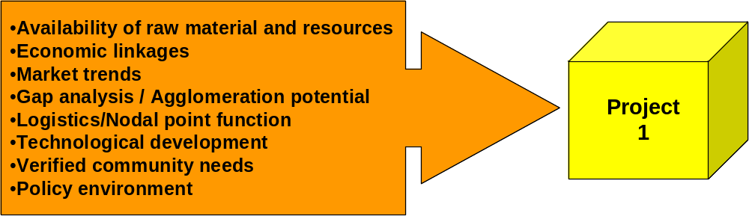

Figure 9.1 illustrates how each project is evaluated in terms of its adherence to or potential for each of the criteria such as e.g. how important it has been ranked in terms of community development, how many linkages it has with other sectors, etc.

The projects that have been identified for the Makhado Municipality are subsequently listed in the next sub-paragraph. It is necessary to distinguish between two main categories of projects. These two categories are:

- Business Projects (Wealth and Employment Creation Projects): These projects aim to create wealth and directly create employment opportunities for the local community of Makhado.
- Municipal Intervention Projects (Development Support Projects): These projects support the strategic development programmes/thrusts as formulated in a previous section and it supports the LED activities throughout the Makhado municipal area. These projects are clearly linked to development programmes.

Based upon the previously discussed potential identification criteria and taking into consideration the numerous constraining elements present within the Study Area, potential for development are summarised in Table 9.1 below. Cognisanze must be taken of the fact that the list includes current LED projects and potential new projects. Some of the projects have been implemented by the IDP of Makhado.

PROJECT EVALUATION

To determine which of the potential projects will have the highest impact on the economy in terms of job creation, capacity building, social upliftment, etc. it is important to prioritise these projects according to a specific set of criteria, which will facilitate the selection process of strategic anchor projects. Figure 9.2 indicates the seven criteria that are used to prioritise planned projects within Westonaria/Bekkersdal. Anchor projects are those projects that consist of a number of linkages to various other sectors and projects.

Figure 9.2: Project Prioritisation Criteria

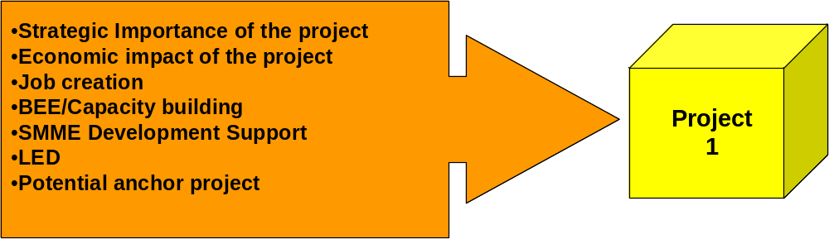

Table 9.1: Identified LED Projects for Makhado | STRATEGIC IMPORTANCE | ECONOMIC IMPACT | JOB CREATION | BEE / CAPACITY BUILDING | SMME DEVELOPMENT SUPPORT | LED | POTENTIAL ANCHOR PROJECTS | PROJECT EVALUATION |  |  | VALUE | PRIORITY
PROJECT |  |  |  |  |  |  |  | HIGH IMPACT (3) | MEDIUM IMPACT (2) | LOW IMPACT (1) | VALUE | PRIORITY
THRUST 1: OVERCOMING THE CONSTRAINTS TO ECONOMIC DEVELOPMENT
Promoting trust and co-operation between Municipality and rest of Makhado | 3 | 3 | 2 | 2 | 2 | 3 | 1 | 3 | 3 | 1 | 50.00 | 3
Central Business District revitalisation/strengthening | 3 | 3 | 2 | 2 | 2 | 3 | 3 | 4 | 3 | 0 | 58.00 | 1
Attract investment to Makhado | 3 | 3 | 2 | 2 | 2 | 3 | 2 | 3 | 4 | 0 | 54.00 | 2
Assist Businesses to develop niche markets | 2 | 2 | 1 | 2 | 2 | 2 | 1 | 0 | 5 | 2 | 34.00 | 4
Improve level of cross border cooperation | 2 | 2 | 1 | 1 | 2 | 2 | 1 | 0 | 4 | 3 | 30.00 | 5
THRUST 2: CREATING AN ENABLING ENVIRONMENT
Government outreach and visitation programme | 3 | 2 | 2 | 2 | 2 | 3 | 2 | 2 | 5 | 0 | 50.00 | 3
Infrastructure provision and maintenance | 3 | 3 | 2 | 3 | 3 | 3 | 3 | 6 | 1 | 0 | 66.00 | 1
Overcoming SMME and entrepreneurial barriers | 3 | 2 | 3 | 2 | 3 | 3 | 1 | 4 | 2 | 1 | 54.00 | 2
Regulatory Reform and the Revision of By-Laws and Development Procedures | 3 | 3 | 2 | 2 | 3 | 2 | 2 | 3 | 4 | 0 | 54.00 | 2
Investment Attraction and Business Retention and Expansion Drive | 3 | 2 | 2 | 2 | 2 | 3 | 2 | 2 | 5 | 0 | 50.00 | 3
THRUST 3: SMME & ENTREPRENEURSHIP DEVELOPMENT
Entrepreneurial Competitions | 2 | 3 | 3 | 2 | 3 | 3 | 3 | 5 | 2 | 0 | 62.00 | 1
Business Skills Development | 3 | 2 | 2 | 2 | 3 | 3 | 2 | 3 | 4 | 0 | 54.00 | 2
Management Development | 2 | 2 | 2 | 2 | 2 | 3 | 2 | 1 | 6 | 0 | 46.00 | 3
Provision of Business Development Support | 3 | 2 | 2 | 2 | 2 | 2 | 1 | 1 | 5 | 1 | 42.00 | 4
Market penetration and geographic expansion drive for SMME’s | 3 | 3 | 2 | 2 | 3 | 3 | 3 | 5 | 2 | 0 | 62.00 | 1
THRUST 4: SECTORAL DEVELOPMENT
TOURISM
Rationalize the tourism institutional infrastructures in the area | 3 | 2 | 2 | 2 | 3 | 3 | 2 | 3 | 4 | 0 | 54.00 | 2
Put in place a tourism marketing forum to fine tune and oversee the implementation of the marketing strategy^ | 3 | 3 | 2 | 2 | 3 | 3 | 2 | 4 | 3 | 0 | 58.00 | 1
Make the Venda “Heartland” a Visitor-Friendly Destination within the overall Soutpansberg destination^ | 3 | 2 | 3 | 2 | 3 | 2 | 2 | 3 | 4 | 0 | 54.00 | 2
Create a new Tourism mode in the Western Soutpansberg Area^ | 2 | 3 | 2 | 2 | 2 | 3 | 2 | 2 | 5 | 0 | 50.00 | 3
Provide Tangible Support to the Three Existing “Route” Initiatives^ | 3 | 2 | 2 | 1 | 2 | 3 | 2 | 2 | 4 | 1 | 46.00 | 4
Create a mini-destination at Spies Dam^ | 2 | 2 | 3 | 2 | 2 | 2 | 2 | 1 | 6 | 0 | 46.00 | 4
Rehabilitate the Schoemansdal Historical Site^ | 2 | 1 | 1 | 1 | 1 | 2 | 1 | 0 | 2 | 5 | 22.00
Support the Soutpansberg Biosphere Initiative^ | 3 | 1 | 1 | 1 | 1 | 3 | 1 | 2 | 0 | 5 | 30.00
Investigate how Donkeys Could Be Used to Create Innovative New Tourism Products and Experiences^ | 2 | 2 | 2 | 1 | 2 | 2 | 2 | 0 | 6 | 1 | 38.00 | 5
Tourism Guide Training | 3 | 2 | 3 | 3 | 2 | 3 | 2 | 4 | 3 | 0 | 58.00 | 1
Publish an information guide for potential tourism investors^ | 2 | 3 | 1 | 1 | 2 | 2 | 1 | 1 | 3 | 3 | 34.00 | 6
Human resource development in the tourism industry | 3 | 3 | 2 | 2 | 2 | 3 | 2 | 3 | 4 | 0 | 54.00 | 2
Wood Carving and Sculptures – Arts and Craft Centre | 3 | 3 | 3 | 2 | 2 | 3 | 2 | 4 | 3 | 0 | 58.00 | 1
Develop tourist packages to Makhado | 3 | 2 | 2 | 2 | 2 | 3 | 2 | 2 | 5 | 0 | 50.00 | 3
Khomanani Paper Art^ | 2 | 2 | 3 | 2 | 2 | 2 | 2 | 1 | 6 | 0 | 46.00 | 4
Mkondeni Potters^ | 2 | 2 | 3 | 2 | 2 | 2 | 2 | 1 | 6 | 0 | 46.00 | 4
AGRICULTURE
Supporting emerging farmers | 3 | 3 | 3 | 2 | 2 | 3 | 2 | 4 | 3 | 0 | 58.00 | 2
Support commercial farmers | 3 | 3 | 3 | 2 | 2 | 3 | 2 | 4 | 3 | 0 | 58.00 | 2
Develop agricultural niche markets | 3 | 3 | 3 | 2 | 3 | 3 | 3 | 6 | 1 | 0 | 66.00 | 1
Dieteleni Poultry project* | 2 | 2 | 2 | 2 | 2 | 2 | 2 | 0 | 7 | 0 | 42.00 | 4
Sinkutla Gardening project* | 2 | 2 | 2 | 2 | 2 | 2 | 2 | 0 | 7 | 0 | 42.00 | 4
Sedzani farming project* | 2 | 2 | 2 | 2 | 2 | 2 | 2 | 0 | 7 | 0 | 42.00 | 4
Njhakanjaka Community Garden* | 2 | 2 | 2 | 2 | 2 | 2 | 2 | 0 | 7 | 0 | 42.00 | 4
Divuseni Piggery* | 2 | 2 | 2 | 2 | 2 | 2 | 2 | 0 | 7 | 0 | 42.00 | 4
Vyeboom community gardening* | 2 | 2 | 2 | 2 | 2 | 2 | 2 | 0 | 7 | 0 | 42.00 | 4
Fhatuwani Tshirangadzi Poultry Project* | 2 | 2 | 2 | 2 | 2 | 2 | 2 | 0 | 7 | 0 | 42.00 | 4
Maelula Poultry Preoject* | 2 | 2 | 2 | 2 | 2 | 2 | 2 | 0 | 7 | 0 | 42.00 | 4
Mamuhobi Piggery* | 2 | 2 | 2 | 2 | 2 | 2 | 2 | 0 | 7 | 0 | 42.00 | 4
Fhatuwani Community Gardening* | 2 | 2 | 2 | 2 | 2 | 2 | 2 | 0 | 7 | 0 | 42.00 | 4
Muduluni Community Garden* | 2 | 2 | 2 | 2 | 2 | 2 | 2 | 0 | 7 | 0 | 42.00 | 4
Zamekomste Poultry Project* | 2 | 2 | 2 | 2 | 2 | 2 | 2 | 0 | 7 | 0 | 42.00 | 4
Zamekomste Community Gardening* | 2 | 2 | 2 | 2 | 2 | 2 | 2 | 0 | 7 | 0 | 42.00 | 4
Manavhela Poultry Project* | 2 | 2 | 2 | 2 | 2 | 2 | 2 | 0 | 7 | 0 | 42.00 | 4
Murunwa gardening and bakery* | 2 | 2 | 2 | 2 | 2 | 2 | 2 | 0 | 7 | 0 | 42.00 | 4
Maelula Poultry* | 2 | 2 | 2 | 2 | 2 | 2 | 2 | 0 | 7 | 0 | 42.00 | 4
Makungwi Poultry* | 2 | 2 | 2 | 2 | 2 | 2 | 2 | 0 | 7 | 0 | 42.00 | 4
Mamuhohi Piggery* | 2 | 2 | 2 | 2 | 2 | 2 | 2 | 0 | 7 | 0 | 42.00 | 4
Mandiwana Poultry* | 2 | 2 | 2 | 2 | 2 | 2 | 2 | 0 | 7 | 0 | 42.00 | 4
Tshiendeulu Poultry* | 2 | 2 | 2 | 2 | 2 | 2 | 2 | 0 | 7 | 0 | 42.00 | 4
Langanani Gardening* | 2 | 2 | 2 | 2 | 2 | 2 | 2 | 0 | 7 | 0 | 42.00 | 4
Funnyufunyu Piggery* | 2 | 2 | 2 | 2 | 2 | 2 | 2 | 0 | 7 | 0 | 42.00 | 4
Gundo Ramavhoya Poultry* | 2 | 2 | 2 | 2 | 2 | 2 | 2 | 0 | 7 | 0 | 42.00 | 4
Rabali Poultry* | 2 | 2 | 2 | 2 | 2 | 2 | 2 | 0 | 7 | 0 | 42.00 | 4
Phadzima Poultry* | 2 | 2 | 2 | 2 | 2 | 2 | 2 | 0 | 7 | 0 | 42.00 | 4
Thasululo Poultry and Piggery* | 2 | 2 | 2 | 2 | 2 | 2 | 2 | 0 | 7 | 0 | 42.00 | 4
Manyii Poultry* | 2 | 2 | 2 | 2 | 2 | 2 | 2 | 0 | 7 | 0 | 42.00 | 4
Mamvuka Poultry* | 2 | 2 | 2 | 2 | 2 | 2 | 2 | 0 | 7 | 0 | 42.00 | 4
Masan Ya Dyambu Poultry* | 2 | 2 | 2 | 2 | 2 | 2 | 2 | 0 | 7 | 0 | 42.00 | 4
Pfananani Garden* | 2 | 2 | 2 | 2 | 2 | 2 | 2 | 0 | 7 | 0 | 42.00 | 4
Donkerhoek Garden* | 2 | 2 | 2 | 2 | 2 | 2 | 2 | 0 | 7 | 0 | 42.00 | 4
Cherry Chilli Production – Farm Klein Afrika | 2 | 3 | 3 | 2 | 2 | 3 | 2 | 3 | 4 | 0 | 54.00 | 3
Klein Afrika – Breeding Program | 2 | 3 | 3 | 2 | 2 | 3 | 2 | 3 | 4 | 0 | 54.00 | 3
MANUFACTURING SECTOR
Local beneficiation processes – agro-processing | 3 | 3 | 3 | 2 | 3 | 3 | 3 | 6 | 1 | 0 | 66.00 | 1
Timber manufacturing and forestry services | 2 | 3 | 3 | 3 | 2 | 3 | 2 | 4 | 3 | 0 | 58.00 | 3
Brick Making | 2 | 2 | 3 | 2 | 2 | 3 | 2 | 2 | 5 | 0 | 50.00 | 5
Leather for Furniture | 2 | 3 | 3 | 2 | 2 | 3 | 2 | 3 | 4 | 0 | 54.00 | 4
Abbatoir - and Deboning Facility | 2 | 3 | 3 | 2 | 2 | 3 | 2 | 3 | 4 | 0 | 54.00 | 4
Bone meal processing | 2 | 2 | 3 | 2 | 2 | 3 | 2 | 2 | 5 | 0 | 50.00 | 5
Food modification projects | 3 | 3 | 2 | 2 | 2 | 3 | 3 | 4 | 3 | 0 | 58.00 | 3
Proposed Manaledzi Plaza (Petrol/Diesel Depot) | 2 | 3 | 3 | 2 | 3 | 3 | 3 | 5 | 2 | 0 | 62.00 | 2
Salt Mining/Exploration | 2 | 3 | 2 | 2 | 2 | 3 | 2 | 2 | 5 | 0 | 50.00 | 5
Recycling: Industrial Waste Disposal and Equipment | 3 | 2 | 3 | 2 | 2 | 3 | 2 | 3 | 4 | 0 | 54.00 | 4
Fruit and Vegetable Processing: Dehydration of Fruits and Vegetables; Citrus and Vegetable Juice; Herbs and Spices production and processing; | 2 | 3 | 3 | 3 | 2 | 3 | 3 | 5 | 2 | 0 | 62.00 | 2
Clothing Manufacturor(combining some of the sewing projects into one project) | 2 | 3 | 3 | 2 | 2 | 3 | 2 | 3 | 4 | 0 | 54.00 | 4
Brick Making (21 Projects)* | 3 | 3 | 3 | 2 | 1 | 3 | 2 | 4 | 2 | 1 | 54.00 | *
Bakery (9 Projects)* | 2 | 2 | 3 | 2 | 2 | 3 | 2 | 2 | 5 | 0 | 50.00 | *
Sewing (14 Projects)* | 2 | 3 | 3 | 2 | 2 | 3 | 2 | 3 | 4 | 0 | 54.00 | *
Multipurpose (10 Projects)* | Insufficient Info | Insufficient Info | Insufficient Info | Insufficient Info | Insufficient Info | Insufficient Info | Insufficient Info |  |  |  |  | -
Other
Vhugala Pest Control* | 2 | 2 | 2 | 2 | 2 | 3 | 2 | 1 | 6 | 0 | 46.00 | 3
Pfano Peanut Butter* | 2 | 3 | 2 | 2 | 2 | 3 | 2 | 2 | 5 | 0 | 50.00 | 2
Mamuhohi Buttery* | 2 | 3 | 1 | 2 | 2 | 2 | 2 | 1 | 5 | 1 | 42.00 | 4
Tshiendeulu Wire Mesh* | 2 | 2 | 2 | 2 | 2 | 2 | 2 | 0 | 7 | 0 | 42.00 | 4
Phadzima floor polish and candle making* | 2 | 3 | 3 | 2 | 2 | 3 | 2 | 3 | 4 | 0 | 54.00 | 1
Kutelezwau jam and peanut butter* | 2 | 2 | 3 | 2 | 2 | 3 | 2 | 2 | 5 | 0 | 50.00 | 2
Thanyani Magau Fencing* | 2 | 2 | 3 | 2 | 2 | 3 | 2 | 2 | 5 | 0 | 50.00 | 2
*=Projects listed by Municipality - Status Unknown
^=Projects identified in the Tourism marketing and Development Plan (STRITA)

Figure 9.3 illustrates economic activities that can be derived from agriculture diversification and beneficiation. It is important to note that in most instances, these anchor projects are also referred to as primary projects, because without the successful implementation of the primary projects, and delivery of primary products there can be no secondary projects such as processing (value-adding to the product) or trade of the finished product/goods.

Figure 9.3 – Anchor Projects
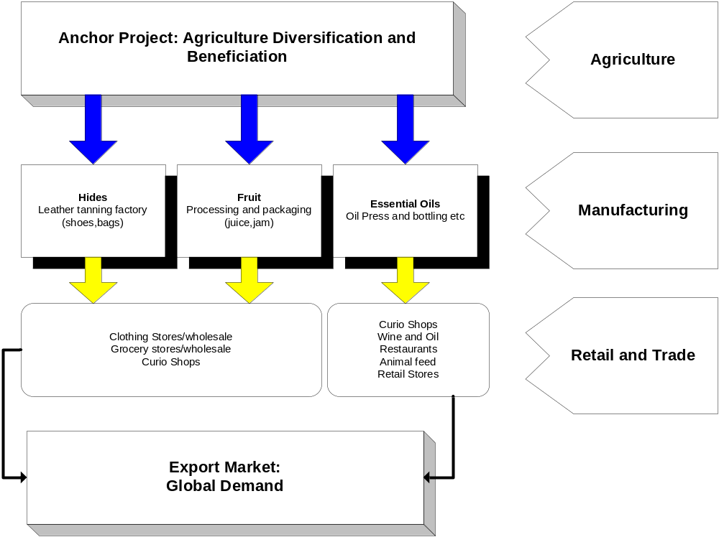

The link that is formed between the product and the consumer is referred to as the value chain. A value chain is therefore the path that a primary product follows where value is added to the product at each destination until it reaches the consumer.

PROJECT EVALUATION CRITERIA

The prioritisation criteria encompass a number of variables which influences the potential outcome of each project’s prioritisation score. Each criterion’s characteristics are discussed in the following paragraphs. A standard evaluation sheet will be used on which all projects will be evaluated.

CRITERION 1: STRATEGIC IMPORTANCE

The following questions should be asked when evaluating the possible projects in terms of its strategic importance.

  - Does the project exploit the comparative advantages (e.g. locational and resource base) of the area?
  - Does the project create and / or strengthen forward or backward linkages with other activities or sectors in order to generate a maximum multiplier effect?
  - Does the project align with the requirements / expectations of the local / recipient community?
  - What is the level of buy-in and commitment by the direct stakeholders?
  - Does the project comply with the IDP principles of the area?
  - Has there been any research done on the project, or are there any other projects that can be used as models / templates?

Strategic importance refers to the holistic magnitude of the potential impact of the project on the local economy. This factor takes considerations into account such as the scale of the development, the chances of being duplicated elsewhere as well as the effects that the project will have on the comparative advantage of the local economy as a whole.

Apart form the mentioned benefits; a project will obtain a high score in this category if it has strong linkages with other potential projects. In other words the successful implementation of the project results in the creation of other potential projects or linkages within the local economy.

CRITERION 2 AND 3: ECONOMIC IMPACT AND JOB CREATION

The following questions should be asked when evaluating the impact of a project:

  - The estimated number of direct jobs to be generated.
  - Long term sustainability of these jobs.
  - Ability to improve the skill / capacity level.

The evaluation of a project in the light of its probable impact on the economy is the second criteria utilised during the assessment process. Economic impact refers to the sum of the projects’ influences on the local economy. This implies that all the different impacts are taken into account. These impacts refer to aspects such as: Increased / additional levy income, new business sales, potential multiplying effects and advantages and foreign direct investments.

It is evident that the specific effects of each of the factors mentioned above are directly associated with the establishment of the project.

CRITERION 4 AND 5: BEE/CAPACITY BUILDING AND SMME DEVELOPMENT/SUPPORT

The promotion, establishment and expansion of SMMEs are weighed against the establishment of large firms. Large firms are mostly multi-locational operations. They are less dependent on their geographic location than SMMEs and do not perceive the local level as a high-priority level of action. They are rarely part of local economic development initiatives and usually deal directly with national government when contributions to development are made. If a given location does not offer satisfactory conditions, it is not rare that a large firm/factory will close down its operation and move elsewhere rather than getting involved in the cumbersome effort of getting involved in a local dialog to negotiate for new incentives and/or services.

The following considerations are kept in mind when a potential project is measured in terms of SMME development:

  - Will the proposed project/SMME development make use of local resources and skills?
  - Will the proposed project cater for SMME/small business skills training and assistance?
  - Will the proposed project promote the potential establishment or expansion of start-up SMMEs?
  - Does a proposed SMME have the necessary networking and business contacts?
  - Will the proposed SMME/project be sufficiently linked to the primary and tertiary sectors of the economy?
  - Is there sufficient effective demand for the proposed product or service?

CRITERION 6 AND 7: LED AND POTENTIAL ANCHOR PROJECTS

The following questions should be asked when evaluating the importance of a project in terms of its feasibility:

  - What is the level of business risk?
  - Will the project be able to become self-sufficient?
  - What are the estimated capital requirements?
  - How easy can the inputs be obtained?
  - What is the level of competition in the particular industry?
  - What are the barriers of entry into the industry?
  - How effective is the demand?

As the implementation of any project is dependant on the financial feasibility of the project, it is vitally important to include associated indicators into the overall project assessment. Aspects such as existing research on the project topic as well as the availability of resources, skills and appropriate technology affect the individual project’s assessment.

In addition other economic indicators/characteristics are incorporated such as increased multiplier effects, etc. Because projects needed in the local economy must be able to facilitate the establishment of future projects, their ability to act as potential anchor projects are evaluated. The evaluation takes factors into account such as:

  - The ability to attract other activities to the region
  - The potential to establish linkages with existing activities
  - The capacity to create multiple advantages within the region

The coordinated implementation of the listed projects will ensure that the economic development of Makhado will be stimulated. Table 9.1 also illustrates the LED projects for Makhado after they have been prioritised.

CONCLUSION

In this section, LED projects was identified and prioritised according to certain criteria. In order to implement the various development programmes formulated in the strategy, the various institutional arrangement have to be initiated and established as a matter of urgency, hence the majority of the proposed projects are aimed towards municipal intervention. These drivers of the LED process throughout Makhado will probably not succeed if the political ambition is not included in the implementation process as a whole. Therefore the inclusion of all the role players and stakeholders throughout the planning and implementation process should initiate political will, generate interest and stimulate dialogue. It is critically important that the role players in the Makhado Municipality take ownership of this regeneration strategy to facilitate the implementation of the development programmes as soon as possible. The monitoring and evaluation of the various activities should be incorporated into the performance management system of the Municipality. This will ensure that accountability and responsibility for implementation is allocated and that potential conflicts avoided.

